Croft Medical Centre

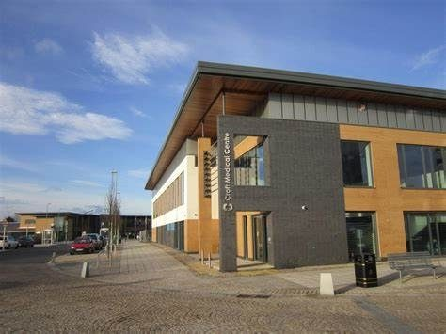
Welcome to Croft Medical Centre
This short booklet offers information on practice opening hours and staff. Please read it carefully and keep it handy for future reference. You can also find all information on our website.
www.craigcroftmedicalcentre.co.uk
www.facebook.com/CroftB37

1 Pomeroy Way
Chelmsley Wood
B37 7WB

0121 270 7180
Prescription requests: prescriptions.croft@nhs.net
General Enquiries (NO APPOINTMENT REQUESTS): admin.croftmc37@nhs.net
Doctors
Dr Michael Bosworth (Partner) MBChB, DRCOG
Dr Qasim Bhatti (Partner) MBChB, DRCOG, nMRCGP, MSc(honors)
Dr Alicia Baker (Partner) MBChb, MRCS(Ed),MRCGP, MSc(honors)
Dr Alison Hales MBChB, DRCOG
Dr Shazli Khan BSc, MBChB, MRCGP, DCH, DFSRH, CME
Dr Srividya Balasubramanian MS MRCGP DRCOG DFFP

Nurse Practitioners
Nicholas Green – Nick is a Nurse Practitioner, specialising in Acute Medicine and Mental Health.
Claire Jones – Claire is and Advanced Nurse Practitioner (ANP) specialising in Respiratory
Melanie Edwards - Mel is a Nurse Practitioner

Nursing Team
Claire Mason – Nurse Prescriber, specialising in Contraceptive Services including Implant & Coil fitting, and Respiratory Disease, ARTP qualified in spirometry.
Jacqui Rea – Nurse with special interest in Respiratory Disease, Cancer Care, Dementia and Rheumatology Care.
Christine Graves - Nurse Prescriber. Specialist interest in contraception including implant fitting and sexual health.
Sue Nightingale - Nurse Prescriber. Specialist interest in Diabetes, Coronary Heart Disease and Chronic Kidney Disease.
Elsa Hartill – Nurse Prescriber. Specialist interest in Heart Failure.
Safina Ali – Nurse with specialist interest in Diabetes
Jennifer Murray – Nurse with specialist interest in wound care.

Healthcare Assistants
Joanne Payne / Michelle Earl / Jackie Davies

Reception
Vicky / Tina / Emma / Lorraine / Dee / Allison / Karen / Steph / Aakifah
Admin Team
Wendy / Claire / Michelle / Maisy / Debbie / Jacqui
Management
Sue Rogers – Practice Manager
Emma Clark – Deputy Practice Manager

Opening Hours
Monday 0800-1830
Tuesday 0800-1830
Wednesday 0800-1830
Thursday 0800-1830
Friday 0800-1830
Extended Access Appointments are pre-bookable between 1830-2000 (Mon-Fri) and 0900-1200 (Sat and Sun) at Chelmsley Wood Primary Care Centre.
This site is closed on Saturday, Sunday and Bank Holidays.
Out of Hours Emergency – In the event of urgent medical care outside of surgery hours please call NHS111 for help and advice. For any emergencies, please call 999.
Appointments
Appointments can be booked online or via phone on the day and some appointments are pre bookable up to 2 weeks in advance. Whilst you have every right to request a particular clinician and we will endeavour to accommodate this where available, please note this is not always possible.
Cancellation of Appointments
It can be very frustrating when you need an appointment and there are none left to book. With this in mind we ask that if you do not need an appointment any longer or cannot make a booked appointment, please call and cancel at your earliest opportunity so that we can offer the appointment to someone else.
Home Visits
Patients are requested to call before 10:00 where possible if a home visit is required. Please give the receptionist as much information as possible so that an appropriate visit can be arranged. Home visits are for housebound patients or patients that are physically too ill to leave the house. There is no guarantee on who will conduct the visit and may be a GP or a paramedic.
Prescriptions
We DO NOT take prescription requests over the phone and your request will not be actioned if you call. We do have a dedicated prescription email address prescriptions.croft@nhs.net that you can email in at any time day or night at your convenience. Alternatively you can put a written request into the letterbox at the surgery direct. Repeat prescriptions can also be requested through our online services. (see below) Please allow 48 working hours from ordering a prescription to collection.

Change of Address / Phone number
Please let us know if you change any of your contact details. It is important that we are able to contact you and a lot of our correspondence is now done by text messaging so please make sure we have your up to date phone numbers.
Compliments and Complaints
We will always strive to give excellent patient experience and care, but occasionally processes don’t always go to plan, whether in or out of control. On these occasions we are happy to engage directly with you to discuss any complaints or suggestions on how to improve further. Similarly we love to hear when you’ve had a positive experience! Please feel free to write in to the Practice Manager either by email, admin.croftmc37@nhs.net or by dropping a letter in to the surgery.
Confidentiality
All staff are bound by strict rules of confidentiality.
Online Access
The Practice offer on-line facilities for patients to book appointments, order medication, view allergies and view coded information in their medical records. Speak to a Receptionist to get your personal log in details (photo ID required
As a patient you are entitled to access to your online medical records. Please ask at reception for an application form for this service.

Zero Tolerance
The practice operates a zero tolerance policy towards any form of verbal or physical aggression. We will issue a written warning letter in the 1st instance and any subsequent incident will result in an 8 day removal notice from the practice list. In the event of a police incident at the practice an instant removal from the practice list will be actioned.

Disability Access
Croft Medical Centre is a new building designed with disability access on both floors with a lift facility as well.

Clinics
Along with our GP appointments we also offer the following services:
Asthma Checks Antenatal Clinics
Blood Pressure and Monitoring Postnatal Checks
IUD Coil Fitting Baby Immunisations
Contraception Implant Pill Checks
Cytology Counselling
Joint Injections

New Patient Registration
Our registration forms can be downloaded from the website or collected from reception
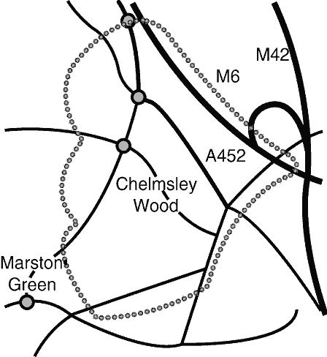
Croft Medical Boundary Area

